CST 206 OPERATING SYSTEMS

MODULE 2

Processes - Process states, Process control block, threads, scheduling, Operations on processes - process creation and termination – Inter-process communication - shared memory systems, Message passing systems.
Process Scheduling – Basic concepts- Scheduling criteria -scheduling algorithms- First come First Served, Shortest Job Firs, Priority scheduling, Round robin scheduling

2. PROCESS
- Process – a program in execution
- Process execution must progress in sequential fashion
- Program is passive entity stored on disk (executable file), process is active entity.
- Program becomes process when executable file loaded into memory
- Execution of program started via GUI mouse clicks, command line
- entry of its name, etc

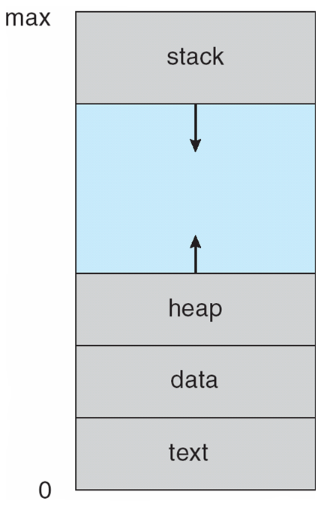
Process in main memory consist of multiple parts
- Text section containing the program code
- Data section containing global and static variables
- Stack containing temporary data,Function parameters, return addresses, local variables
- Heap containing memory dynamically allocated during run time (managed via calls to new, delete, malloc, free, etc.)

Note that the stack and the heap start at opposite ends of the process's free space and grow towards each other. If they should ever meet, then either a stack overflow error will occur, or else a call to new or malloc will fail due to insufficient memory available.

2.1 PROCESS STATES
As a process executes, it changes state
- new: The process is being created
- ready: The process is waiting to be assigned to a processor
- running: Instructions are being executed
- waiting: The process is waiting for some event to occur
- terminated: T
- he process has finished execution

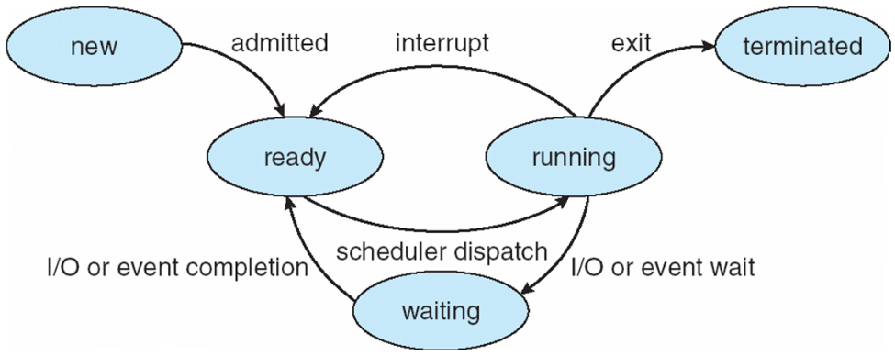

2.2 Process Control Block (PCB)

- Each process is represented in the operating system by a PCB
- PCB holds the information associated with each process
- Also called task control block
- The process control block is kept in a memory area that is protected from the normal user access.
- This is done because it contains important process information.
PCB includes:
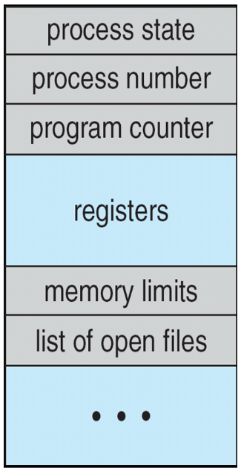
- Process state : The state may be new, ready running, waiting,terminte
- Process number – process id
- Program counter – address of next instruction to execute
- CPU registers – contents of all process-centric registers
- Memory management information – memory allocated to the process
- List of open files- list of files opened for process
- CPU scheduling information- priorities, scheduling queue pointers
- Accounting information – CPU used, clock time elapsed since start, time limits
- I/O status information – I/O devices allocated to process
2.3 THREADS
- when a process is running a word-processor program, a single thread of instructions is being executed.
- This single thread of control allows the process to perform only one task at one time. The user cannot simultaneously type in characters and run the spell checker within the same process, for example.
- Many modern operating systems have extended the process concept to allow a process to have multiple threads of execution and thus to perform more than one task at a time.
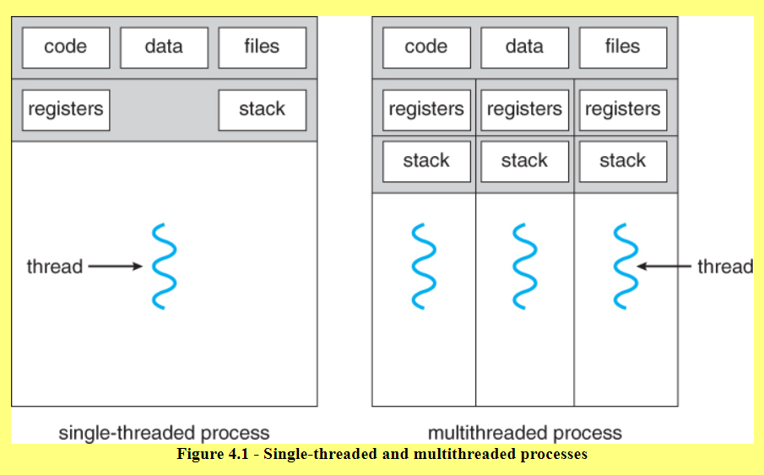
- On a system that supports threads, the PCB is expanded to include information for each thread

Process vs Thread?
■ The primary difference is that threads within the same process run in a shared memory space, while processes run in separate memory spaces.
■ Threads are not independent of one another like processes are, and as a result threads share with other threads their code section, data section, and OS resources (like open files and signals).
■ But, like a process, a thread has its own program counter (PC), register set, and stack space.
Advantages of Thread over Process
1. Responsiveness: If the process is divided into multiple threads, if one thread completes its execution, then its output can be immediately returned.
2. Faster context switch: Context switch time between threads is lower compared to process context switch. Process context switching requires more overhead from the CPU.
3. Effective utilization of a multiprocessor system: If we have multiple threads in a single process, then we can schedule multiple threads on multiple processors. This will make process execution faster.
4. Resource sharing: Resources like code, data, and files can be shared among all threads within a process.(Note: stack and registers can’t be shared among the threads. Each thread has its own stack and registers.)
5. Communication: Communication between multiple threads is easier, as the threads share common address space. While in process we have to follow some specific communication techniques for communication between two processes.
6. Enhanced throughput of the system: If a process is divided into multiple threads, and each thread function is considered as one job, then the number of jobs completed per unit of time is increased, thus increasing the throughput of the system.
○ Types of Threads
■ There are two types of threads.
● User Level Thread ● Kernel Level Thread

2.4 PROCESS SCHEDULING
- The process scheduling is the activity of the OS that handles the removal of the running process from the CPU and the selection of another process on the basis of a particular strategy.
- Process scheduling is an essential part of a Multiprogramming operating systems.
- Such operating systems allow more than one process to be loaded into the executable memory at a time and the loaded process shares the CPU using time multiplexing.
- Maximize CPU use, quickly switch processes onto CPU for time sharing
- Process scheduler selects among available processes for next execution on CPU
Scheduling Queues
- OS maintains different scheduling queues of processes
  - OS maintains a separate queue for different process states and PCBs of all processes in the same execution state are placed in the same queue.
  - When the state of a process is changed, its PCB is unlinked from its current queue and moved to its new state queue.
- Different scheduling queues are:
  - Job queue – set of all processes in the system. When a process is created it is entered into job queue.
  - Ready queue – set of all processes residing in main memory, ready and waiting to execute
  - Device queues – set of processes waiting for an I/O device
- Process migrate among various queues.

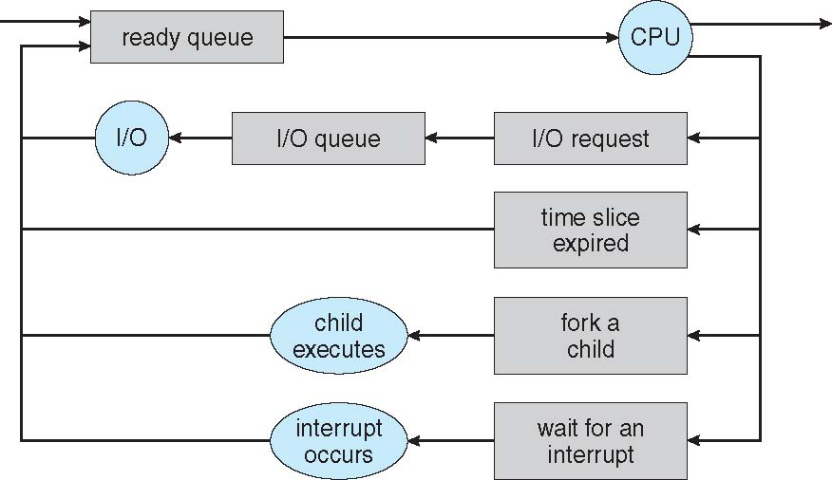
Queuing Diagram - Representation of Process Scheduling
- Queueing diagram represents queues, resources, flows.

SCHEDULERS
- Schedulers are special system software which handle process scheduling.
- Types of process schedulers:
  - Short- term scheduler
  - Long- term scheduler
  - Medium- term scheduler
- Short-term scheduler (or CPU scheduler)
  - Selects which process should be executed next and allocates CPU
  - Short-term scheduler is invoked frequently (milliseconds) Þ (must be fast)
- Long-term scheduler (or job scheduler)
  - Selects which processes should be brought into the ready queue
  - Long-term scheduler is invoked infrequently (seconds, minutes) Þ (may be slow)
  - The long-term scheduler controls the degree of multiprogramming (number of processes in memory).
- Medium – term scheduler
  - A running process may become suspended if it makes an I/O request. A suspended processes cannot make any progress towards completion.
  - In this condition, to remove the process from memory and make space for other processes, the suspended process is moved to the secondary storage.
  - Remove process from memory, store on disk, bring back in from disk to continue execution: swapping
  - Medium-term scheduler takes care of process swapping.
  - Medium-term scheduler reduces the degree of multiprogramming
  - .
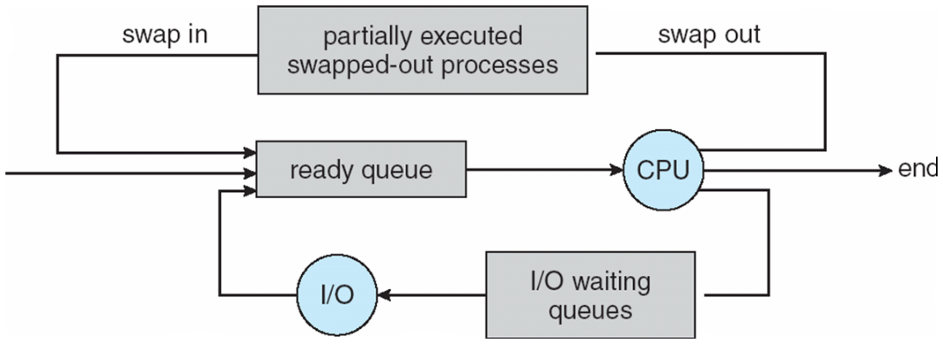

- Processes can be described as either:
  - I/O-bound process – spends more time doing I/O than computations, many short CPU bursts
  - CPU-bound process – spends more time doing computations; few very long CPU bursts
- Long-term scheduler strives for good process mix

CONTEXT SWITCH
- The process of storing the state of the old process and load the saved state for the new process, when CPU switches to another process, is called context switching.
- This allows multiple processes to share a single CPU
- Essential feature of a multitasking operating system.
- Context of a process represented in the PCB
CPU Switch From Process to Process
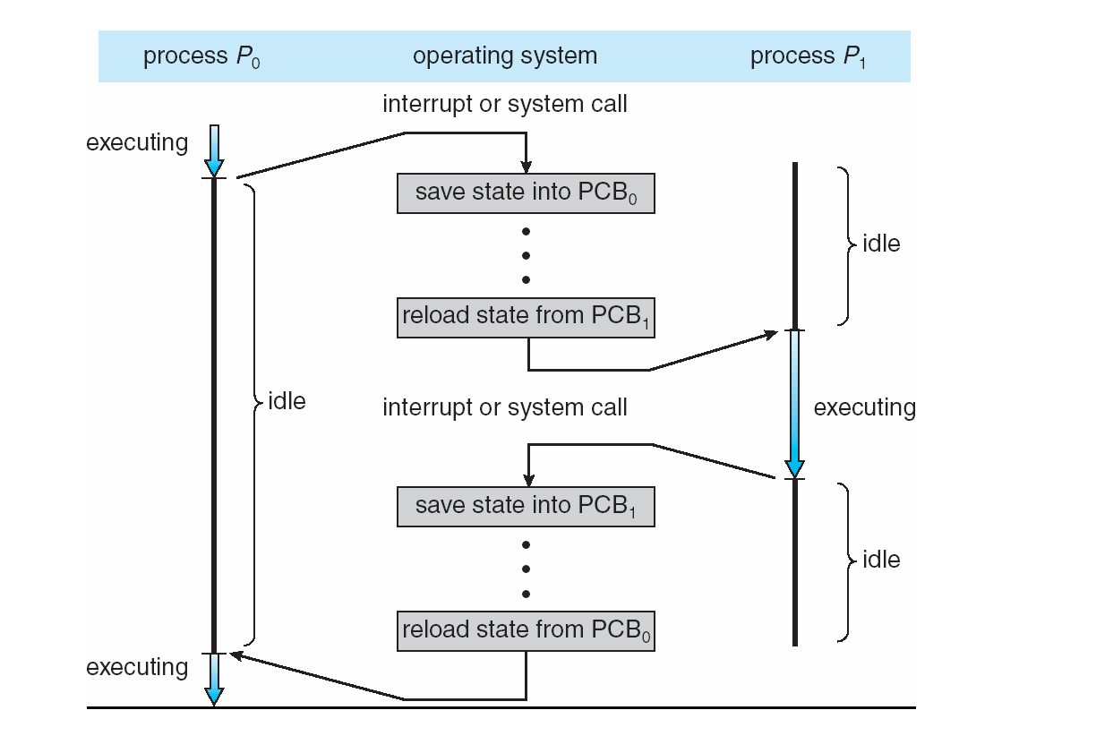

- Context-switch time is overhead; the system does no useful work while switching
  - The more complex the OS and the PCB è the longer the context switch

2.5 OPERATIONS ON PROCESSES
- Operations on processes are:
  - process creation
  - process termination

2.5.1 PROCESS CREATION
- Process creation means the construction of a new process for the execution. This might be performed by system, user or old process itself.
- Parent process create children processes, which, in turn create other processes, forming a tree of processes
(i). When a new process is created, the operating system assigns a unique Process Identifier (PID) to it and inserts a new entry in the primary process table.
(ii). Then the required memory space for all the elements of the process such as program, data and stack is allocated including space for its Process Control Block (PCB).
(iii). Next, the various values in PCB are initialized such as,
■ Process identification part is filled with the PID assigned to it in step (1) and also its parent’s PID.
■ The processor register values are mostly filled with zeroes, except for the stack pointer and program counter.
■ Stack pointer is filled with the address of stack allocated to it in step (ii) and program counter is filled with the address of its program entry point.
■ The process state information would be set to ‘New’.
■ Priority would be lowest by default, but users can specify any priority during creation.
■ In the beginning, the process is not allocated to any I/O devices or files.
■ The user has to request them or if this is a child process it may inherit some resources from its parent.
(vi). Then the operating system will link this process to the scheduling queue and the process state would be changed from ‘New’ to ‘Ready’. Now the process is competing for the CPU.
(v). Additionally, the operating system will create some other data structures such as log files or accounting files to keep track of processes activity.

Fork () system call
- Creates new process
  - Created process is called child process, which runs concurrently with the process that makes the fork() call (parent process).
- After a new child process is created, both processes will execute the next instruction following the fork() system call.

- A child process uses the same pc(program counter), same CPU registers, same
open files which use in the parent process.

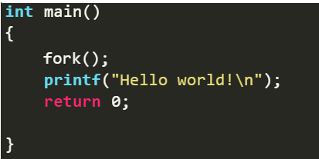
Total Number of Processes created= 2^{n}, where n is number of fork system calls
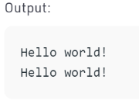

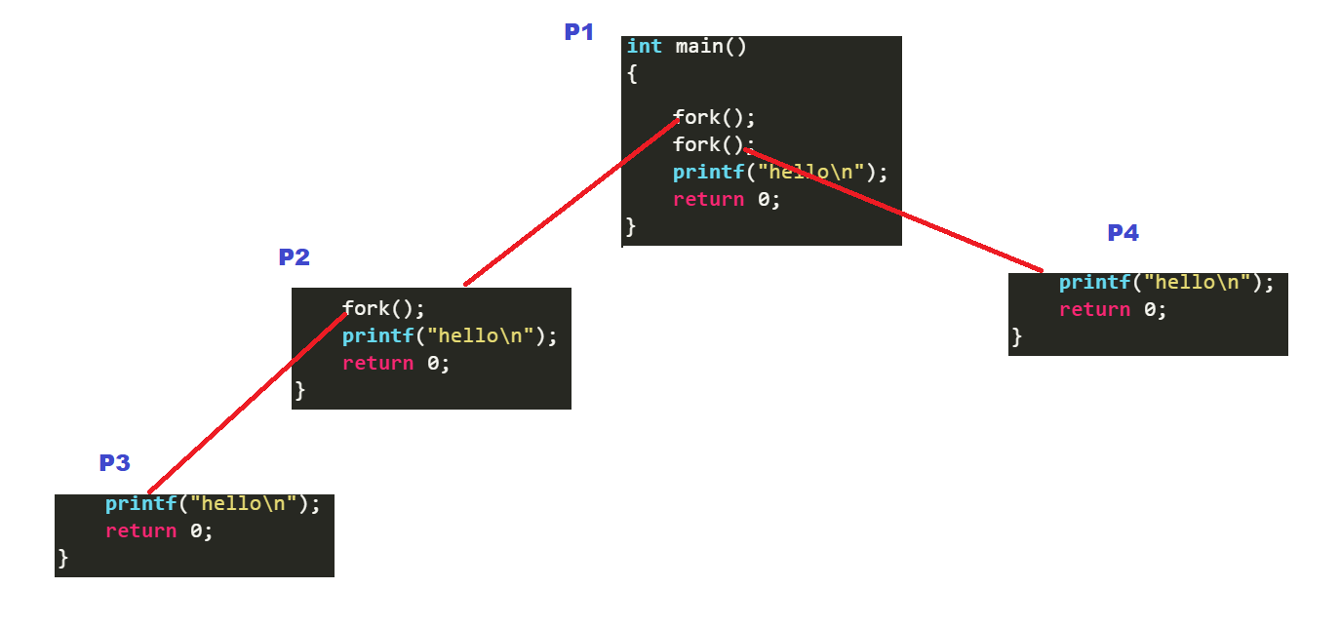
- It takes no parameters
- Returns an integer value.
  - Negative Value - creation of a child process was unsuccessful.
  - Zero: Returned to the newly created child process.
  - Positive value: Returned to parent or caller. The value contains process ID of newly created child process.
exec () system call
- exec() system call used after a fork() to replace the process memory space with a new program
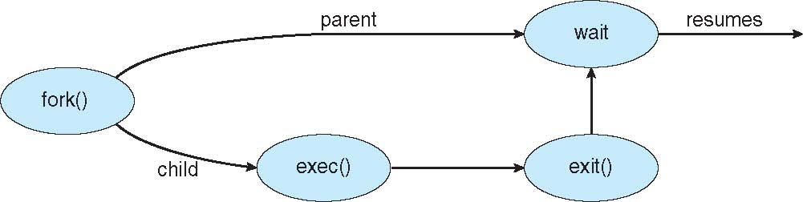
2.5.2 PROCESS TERMINATION
- Process executes last statement and then asks the operating system to delete it using the exit() system call.
  - Returns status data from child to parent (via wait())
  - Process resources are deallocated by operating system
- Parent may terminate the execution of children processes using the abort() system call. Some reasons for doing so:
  - Child has exceeded allocated resources
  - Task assigned to child is no longer required
  - The parent is exiting and the operating systems does not allow a child to continue if its parent terminates
- The parent process may wait for termination of a child process by using the wait()system call. The call returns status information and the pid of the terminated process
pid = wait(&status);
- Some operating systems do not allow child to exists if its parent has terminated. If a process terminates, then all its children must also be terminated.

- cascading termination - All children, grandchildren, etc. are terminated. The termination is initiated by the operating system.

- Zombie process :A zombie process is a process whose execution is completed but it still has an entry in the process table.
Once the parent process reads the child’s exit status, the zombie process is eliminated from the process table. This is known as reaping the zombie process.
- Orphan process
  - An orphan process is a process that is still executing, but whose parent has died.
OTHER OPERATIONS ON PROCESS
- Process Blocking
  - When a process invokes an input-output system call, OS blocks that process
- Process Preemption
  - When a timeout occurs (that means the process hadn’t been terminated in the allotted time interval and next process is ready to execute) then the operating system preempts the process.
  - This operation is only valid where CPU scheduling supports preemption.

2.6 INTERPROCESS COMMUNICATION
- Processes executing concurrently in the OS may be
  - Independent process
  - Cooperating process
Independent process
They cannot affect or be affected by other processes executing in the system.
Cooperating process
The can affect or be affected by other processes, executing in the system. Any process that share data with other process is a cooperating process.
Reasons for cooperating processes:
  - Information sharing
  - Computation speedup
  - Modularity
  - Convenience
- Interprocess communication(IPC) is the mechanism provided by the operating system that allows processes to communicate with each other
- Two models of IPC
- Shared memory
    - In shared memory-memory model, a region of memory that is shared by the cooperating process is established.
    - Processes can then exchange information by reading and writing data to the shared region.
- Message passing
In message passing model, communication takes place by means of exchanged messages between cooperating processes
IPC Models

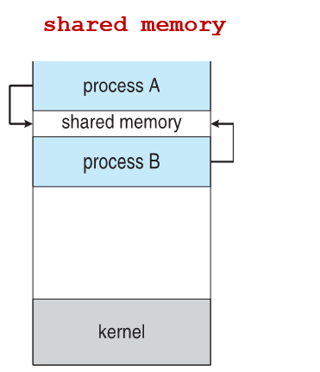
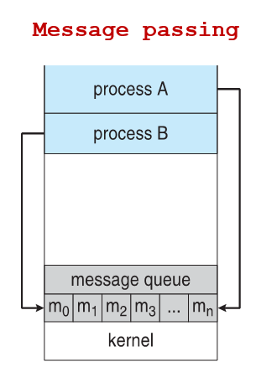
1. Shared Memory:
■ Communication between processes using shared memory requires processes to share some variable, and it completely depends on how the programmer will implement it.
■ One way of communication using shared memory can be imagined like this: Suppose process1 and process2 are executing simultaneously, and they share some resources or use some information from another process.
■ Process1 generates information about certain computations or resources being used and keeps it as a record in shared memory.
■ When process2 needs to use the shared information, it will check in the record stored in shared memory and take note of the information generated by process1 and act accordingly.
■ Processes can use shared memory for extracting information as a record from another process as well as for delivering any specific information to other processes.
Ex: Producer-Consumer problem
● There are two processes: Producer and Consumer.
● The producer produces some items and the Consumer consumes that item.
● The two processes share a common space or memory location known as a buffer where the item produced by the Producer is stored and from which the Consumer consumes the item if needed.
● There are two versions of this problem:
● The Buffer
○ The buffer can be of two types:
● Unbounded buffer ● Bounded buffer
● Unbounded buffer
○ There is no limit on the size of the unbounded buffer.
○ The consumer waits for a new item, however, there is no restriction on the producer to produce items.
● Bounded buffer
○ If the buffer is empty, the consumer must wait for a new item. ○ When the buffer is full, the producer waits until it can produce new items
● We will discuss the bounded buffer problem.
● First, the Producer and the Consumer will share some common memories, then the producer will start producing items.
● If the total produced item is equal to the size of the buffer, the producer will wait to get it consumed by the Consumer.
● Similarly, the consumer will first check for the availability of the item.
● If no item is available, the Consumer will wait for the Producer to produce it. If there are items available, consumers will consume them.
2. Message Passing:
● In this method, processes communicate with each other without using any kind of shared memory.
● If two processes p1 and p2 want to communicate with each other, they proceed as follows:
Establish a communication link (if a link already exists, no need to establish it again.)
● Start exchanging messages using basic primitives.
We need at least two primitives:
– send(message, destination) or send(message)
– receive(message, host) or receive(message)
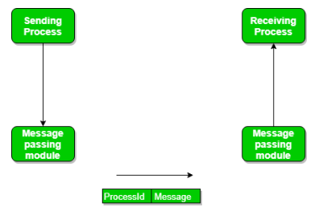
● Here are different ways to communicate using message passing:
1. Direct or Indirect communication
2. Synchronous or asynchronous communication
3. Automatic or explicit buffering

1. Direct or Indirect communication
○ Under Direct communication, processes must explicitly name the sender or receiver in the communication.
○ The send() and receive() are defined as: ■ send(P, message) – send a message to process P
■ receive(Q, message) – receive a message from process Q
○ The communication link in direct communication has the following properties:
■ The link is established automatically. Processes need each other’s identity to send messages.
■ A link is associated with exactly two processes.
■ Between two processes, there is only one link.
○ There is a symmetry in addressing. In asymmetrical addressing, the sending process needs to address the receiver, but the recipient does not need to address the sender.
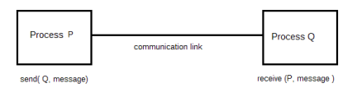
The disadvantage in symmetric and asymmetric schemes is in changing the identifier of a process.
○ We need to change all the other process definitions and references to the old identifier and replace it with the new one.
○ In indirect communication, messages are sent and received from mailboxes or ports.
○ The processes can place messages into a mailbox or remove messages from them.
○ The mailbox has a unique identification.
○ Two processes can communicate only if they have a shared mailbox.
■ send(A, message) – send a message to mailbox A
■ receive(A, message) – receive a message from mailbox A
○ In this scheme, a communication link has the following properties:
1. A link is established between a pair of processes only if both have the same shared mailbox.
2. A link may be associated with more than two processes.
3. There may be different links, with each link corresponding to one mailbox, between pairs of communicating processes.
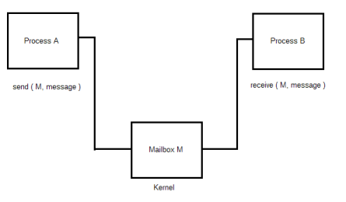
2. Synchronous and Asynchronous Communication
○ Communication happens using send() and receive().
○ There are many options for these two primitives.
○ Message passing may be blocking or non-blocking also known as synchronous and asynchronous.
● Blocking send – sending is blocked, until a message is received by the receiving process or mailbox.
● Non-blocking send – sending process sends the message and resumes operation.
● Blocking receive – receiver blocks until a message is available.
● Non-blocking receive – the receiver retrieves either a valid message or a null.
3.Automatic and Explicit Buffering
○ The messages exchanged between communicating processes reside in a temporary queue.
○ The queue can be implemented in three way:
■ Zero capacity – with zero capacity the link cannot have messages waiting. Blocking send is the correct option.
■ Bounded capacity – the queue is of finite length n. If the queue is not full, the sender can continue to send messages. If full, blocking send.
■ Unbounded capacity – Infinite queue length; any number of messages wait and sender never blocks
○ Zero capacity is called no buffering and other systems called automatic buffering.
2.7 PROCESS SCHEDULING
Basic Concepts
Refer section 2.4
CPU-I/O Burst Cycle
- Process execution consist of a cycle of CPU execution and I/O wait
  - Process alternates between these two states
- CPU burst – time when the process is being executed in the CPU
- I/O burst – time when the process is waiting for I/O operation
- Process execution consists of a cycle of CPU execution and I/O wait
  - CPU burst followed by I/O burst
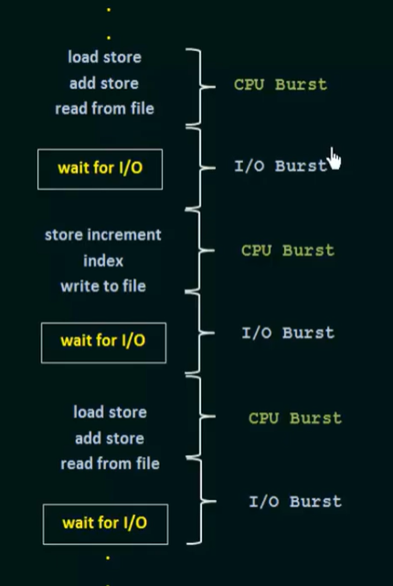
- The final CPU burst ends with a system request to terminate execution

CPU Scheduler
  - Whenever the CPU becomes idle, Short-term scheduler (CPU scheduler) selects from among the processes in ready queue, and allocates the CPU to one of them
  - Queue may be ordered in various ways
Pre-emptive & Non-preemptive Scheduling
  - Non-preemptive scheduling
- Under non-preemptive scheduling, once the CPU has been allocated to a process, the process keeps the CPU until it releases the CPU either by terminating or by switching to the waiting state.

  - Preemptive scheduling
  - CPU scheduling decisions may take place when a process:
  - Switches from running to waiting state
  - Switches from running to ready state
  - Switches from waiting to ready
  - Terminates
  - Scheduling under 1 and 4 is Non preemptive
  - All other scheduling is preemptive
Dispatcher
- Another component involved in CPU scheduling function is dispatcher.
- Dispatcher module gives the control of CPU to the process selected by the short term scheduler.
- This function involves:
  - switching context
  - switching to user mode
  - jumping to the proper location in the user program to restart that program
- Dispatch latency – time it takes for the dispatcher to stop one process and start another running
SCHEDULING CRITERIA
- CPU utilization
  - keep the CPU as busy as possible
- Throughput
  - measure of work done by CPU
  - number of processes that complete their execution per time unit
- Turnaround time
  - amount of time to execute a particular process
  - The interval from the time of submission of a process to the time of completion is turn around time.
  - Turn-around time is the sum of time spent waiting to get into memory, waiting in the ready queue, executing in CPU, and waiting for I/O.
- Waiting time
  - amount of time a process has been waiting in the ready queue
- Response time
  - amount of time it takes from when a request was submitted until the first response is produced, not output
SCHEDULING ALGORITHM - OPTIMIZATION CRITERIA
- Max CPU utilization
- Max throughput
- Min turnaround time
- Min waiting time
- Min response time
2.8 SCHEDULING ALGORITHMS
  - First come First Served Scheduling
  - Shortest Job First Scheduling
  - Priority Scheduling
  - Round Robin Scheduling
  - Multilevel queue scheduling
  - Multilevel feedback queue scheduling
    - First- Come, First-Served (FCFS) Scheduling
- Simplest CPU scheduling algorithm
- The process which arrives first in the ready queue is firstly assigned the CPU.
- The implementation of FCFS policy is easily managed with a FIFO queue.

- When a process enters the ready queue, its PCB is linked onto the tail of the queue.
- When the CPU is free, it is allocated to the process at the head of the queue.
- The running process is then removed from the queue.
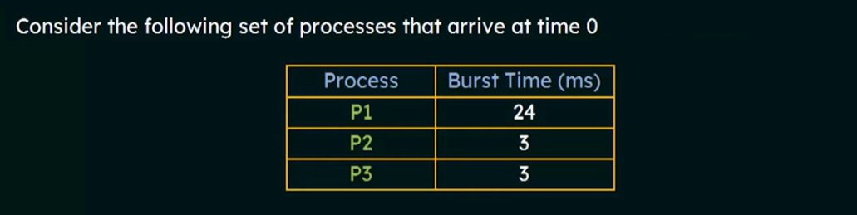
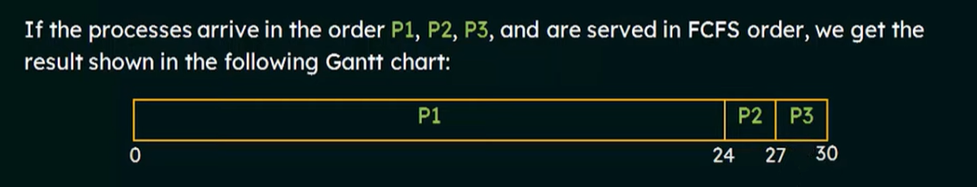

Waiting time for P1 = 0 ms
Waiting time for P2 = 24 ms
Waiting time for P3 = 27 ms
Average waiting time=(0+24+27)/3
- The average waiting time of FCFS policy varies substantially if the processes CPU burst time vary greatly.
- NB: In case of a tie, process with smaller process id is executed first.
- FCFS scheduling is non-preemptive.
  - once CPU time has been allocated to a process, other processes can get CPU time only after the current process has finished.
- Convoy effect
  - In FCFS, if the first process has highest CPU burst time, then the processes of lower burst time may get blocked. This is called convoy effect or starvation.
  - In Convoy Effect, one slow process slows down the performance of the entire set of processes, and leads to wastage of CPU time and other devices.
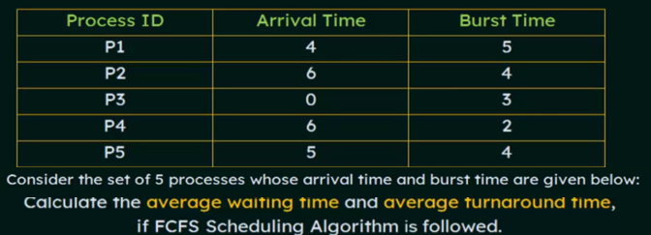
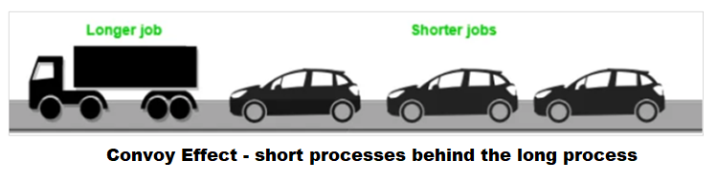

FCFS – Exercises

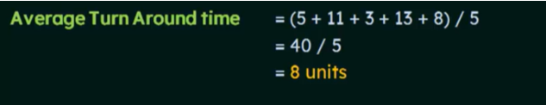
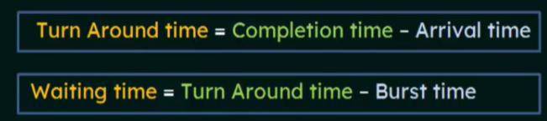
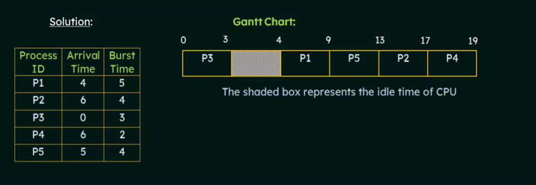
Process ID | Completion Time | Turnaround Time | Waiting Time
P1 | 9 | 9-4=5 | 5-5=0
P2 | 17 | 17-6=11 | 11-4=7
P3 | 3 | 3-0=3 | 3-3=0
P4 | 19 | 19-6=13 | 13-2=11
P5 | 13 | 13-5=8 | 8-4=4
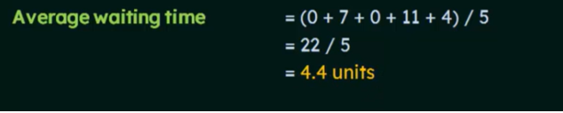

    - SHORTEST-JOB-FIRST (SJF) SCHEDULING

The SJF scheduling algorithm schedules the processes according to their burst time.
○ In SJF scheduling, the process with the lowest burst time, among the list of available processes in the ready queue, is going to be scheduled next.
○ However, it is very difficult to predict the burst time needed for a process hence this algorithm is very difficult to implement in the system.
- A more appropriate term would be – Shortest Next CPU Burst Algorithm
  - Because scheduling depends on the length of next CPU burst of a process, rather than its total length.
○ Advantages of SJF
■ Maximum throughput
■ Minimum average waiting and turnaround time

○ Disadvantages of SJF
■ May suffer with the problem of starvation
■ It is not implementable because the exact Burst time for a process can't be known in advance

SJF can be
  - Non-preemptive
  - Preemptive
SJF Example - non preemptive
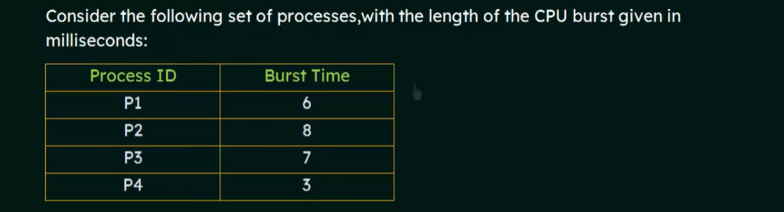
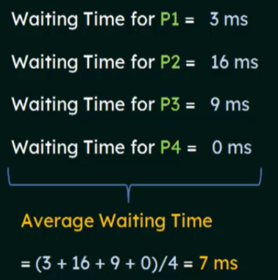
Gantt Chart :

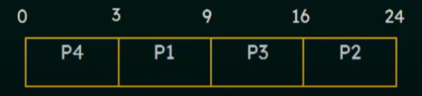
- FCFS – 10.25 ms
- SJF better than FCFS
- SJF is optimal

SJF Example- preemptive
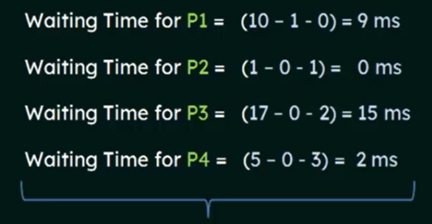
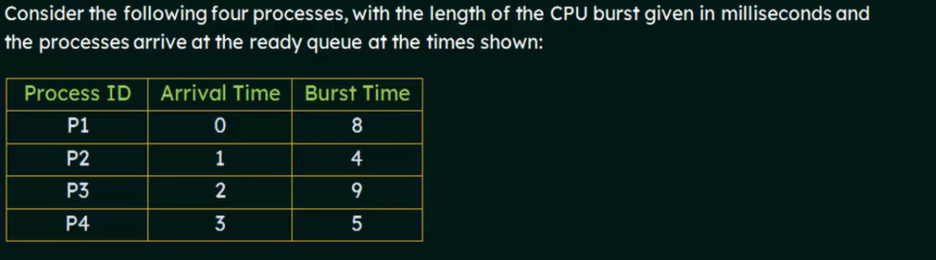
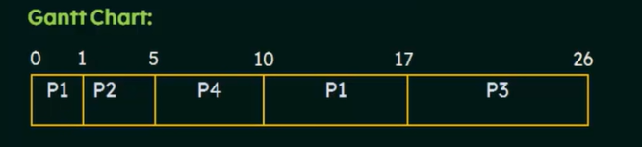
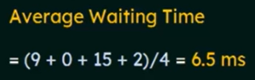
SJF preempted version – shortest remaining time first

2.2 SHORTEST REMAINING TIME FIRST (SRTF) SCHEDULING ALGORITHM
○ This Algorithm is the preemptive version of SJF scheduling.
○ In SRTF, the execution of the process can be stopped after a certain amount of time.
○ At the arrival of every process, the short term scheduler schedules the process with the least remaining burst time among the list of available processes and the running process.
○ Once all the processes are available in the ready queue, No preemption will be done and the algorithm will work as SJF scheduling.
The context of the process is saved in the Process Control Block when the process is removed from the execution and the next process is scheduled.
○ This PCB is accessed on the next execution of this process.
○ Example
■ In this Example, there are five jobs P1, P2, P3, P4, P5 and P6. Their arrival time and burst time are given below in the table.

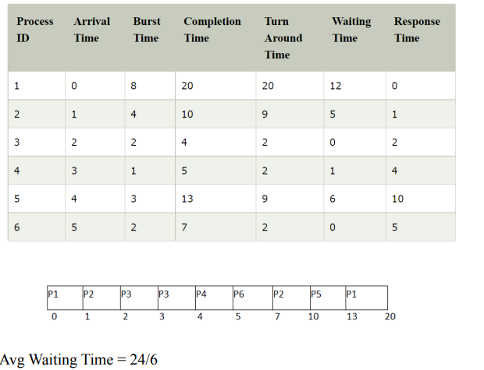

Problems with SJF scheduling
  - The real difficulty with the SJF algorithm is knowing the length of next CPU burst.
  - Not a specific approach to find the length of next CPU burst
  - Some approaches
    - Approximating the length of next CPU burst
    - Exponential averaging
Approximating the length of next CPU burst
  - We expect the length of next CPU burst, will be similar to the length of previous ones.
  - By approximating the value in this way, we can pick the process with the shortest predicted CPU burst.
Exponential Averaging
  - Length of next CPU burst can be computed, by using the length of previous CPU bursts, using exponential averaging
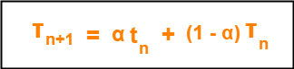
where-
- α is called smoothening factor (0<= α <=1)
- t_{n} = actual burst time of process P_{n}
- T_{n} = Predicted burst time for process P_{n}

    - PRIORITY SCHEDULING
- A priority number (integer) is associated with each process
- The CPU is allocated to the process with the highest priority
  - smallest integer 0 highest priority
  - Equal priority process are scheduled based on FCFS
- An SJF is simply priority scheduling algorithm, where the priority is the inverse of (predicted)next CPU burst time
    - The larger the CPU burst, the lower the priority and vice versa.
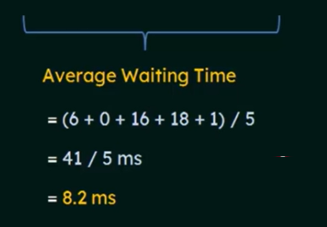
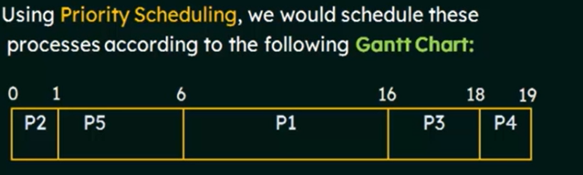
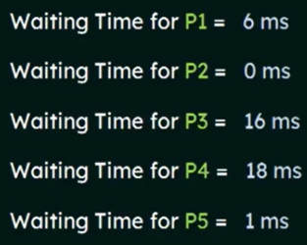
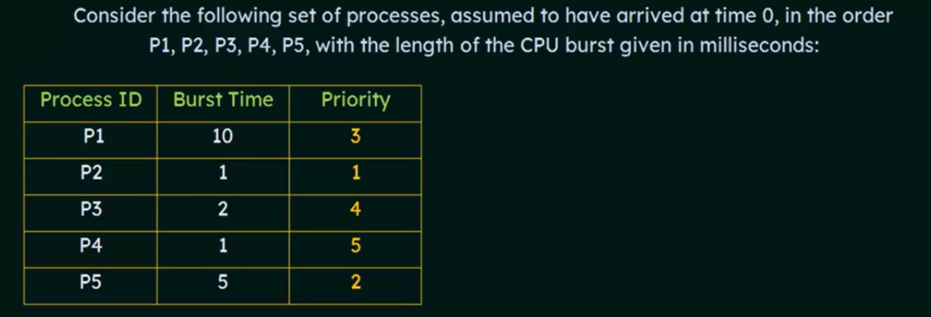All process have same arrival time

Priority scheduling - 2 types
    - Preemptive
      - A preemptive priority scheduling algm will preempt the CPU if the priority of the newly arrived process is higher than the priority of the currently running process.
There are 7 processes P1, P2, P3, P4, P5, P6 and P7 given. Their respective priorities, Arrival Times and Burst times are given in the table below:
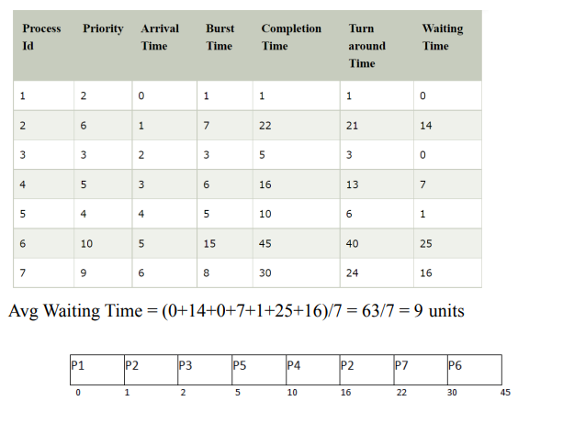
    - Non-preemptive
      - A nonpreemptive priority scheduling algm will simply put the new process at the head of the ready queue.
- In the Example, there are 7 processes P1, P2, P3, P4, P5, P6 and P7. Their priorities, Arrival Time and burst time are given in the table:
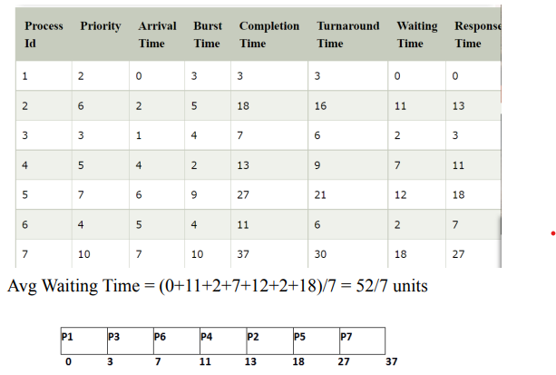
Problem with priority scheduling
- Starvation ( or Indefinite blocking)
  - Priority scheduling algorithm can leave some low priority processes waiting indefinitely.
Solution
- Aging – as time progress increase the priority of the processes that wait in the system for a long time.
- For eg,
  - If priorities range from 127(low) to 0(high), we could increase the priority of a waiting process by 1 every 15 minutes.
  - Eventually, even a process with an initial priority of 127 would have the highest priority in the system and would be executed.
    - ROUND ROBIN (RR) SCHEDULING

Round Robin scheduling algorithm is one of the most popular scheduling algorithms which can actually be implemented in most of the operating systems.
○ This is the preemptive version of first come first serve scheduling.
○ The Algorithm focuses on Time Sharing.
○ In this algorithm, every process gets executed in a cyclic way.
○ A certain time slice is defined in the system which is called time quantum.
○ Each process present in the ready queue is assigned the CPU for that time quantum, if the execution of the process is completed during that time then the process will terminate else the process will go back to the ready queue and wait for the next turn to complete the execution. ○ Advantages
1. It can be actually implementable in the system because it is not dependent on the burst time.
2. It doesn't suffer from the problem of starvation or convoy effect.
3. All the jobs get a fair allocation of CPU.
○ Disadvantages
1. The higher the time quantum, the higher the response time in the system.
2. The lower the time quantum, the higher the context switching overhead in the system.
3. Deciding a perfect time quantum is really a very difficult task in the system.
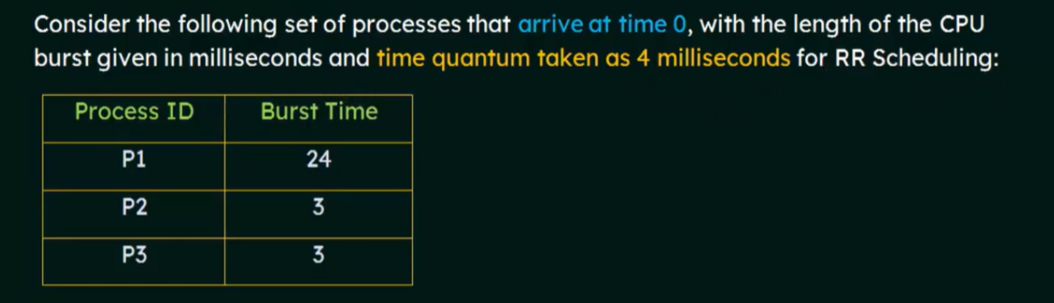
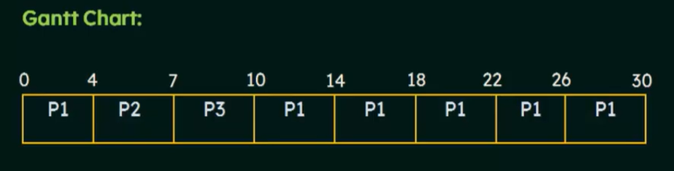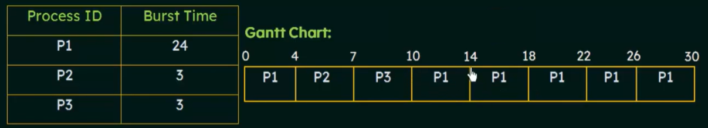
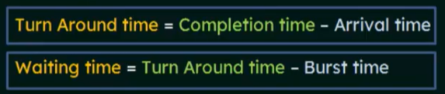

- Mostly used for time sharing OS.
    - Time is shared between different processes.
    - Performance of RR algorithm, depends heavily on the size of time quantum.
- Very big time quantum
    - Same as FCFS
- Very small time quantum
    - Too many context switching
- So have to strike a balance between these two.
    - usually 10-100 milliseconds
- RR – Example 2
In the following example, there are six processes named as P1, P2, P3, P4, P5 and P6. Their arrival time and burst time are given below in the table. The time quantum of the system is 4 units.
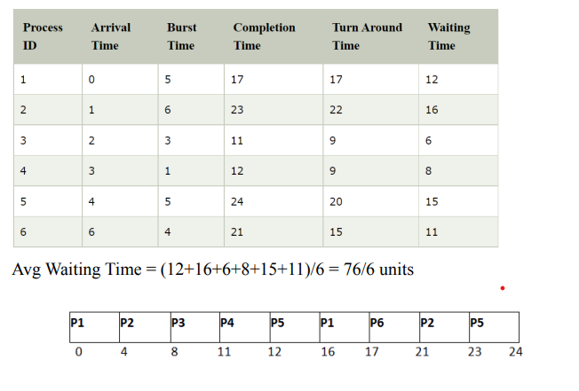
RR – Example 3
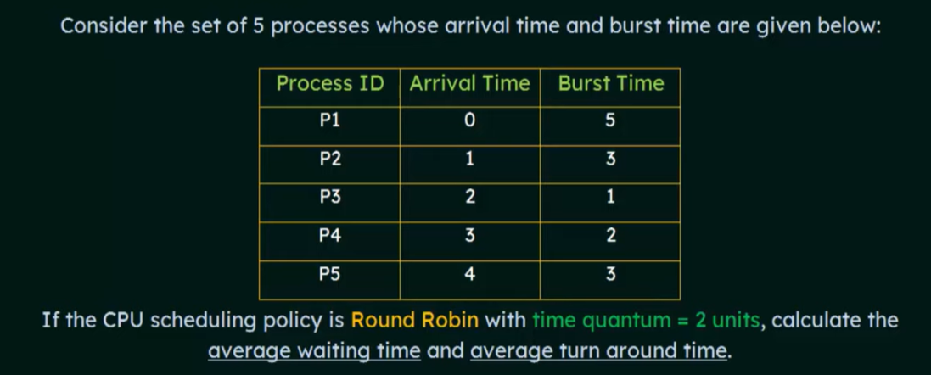
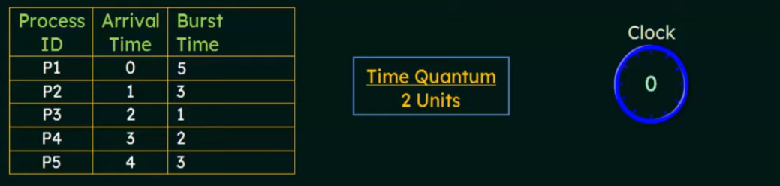
IMPORTANT QUESTIONS
- What is context switch? Why context switch is considered to be an overhead to the system?
- Explain the process creation in Unix with the help of suitable example
- What is a PCB(Process Control Block)?
- List out the List out the advantage of process cooperation.
- Differentiate between Short term, Medium term and Long term schedulers.
- With the help of a suitable example, explain process creation
- What is the main problem with Shortest Job First scheduling and what is its solution?
- Write any three criteria to be considered for comparing CPU scheduling algorithms?
- How indefinite blocking can be solved in priority scheduling
- Find the average waiting time for pre-emptive and non pre-emptive SJF scheduling for the following set of processes
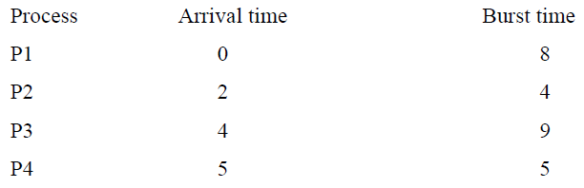

- What is a process? With the help of a diagram, explain the different process states.
- How is IPC using shared memory done?
- What are the functions of a dispatcher?
- Explain how a new process can be created in Unix using fork system call.
- What are the fields in a Process Control Block (PCB)?
- What are the disadvantages of shortest job first algorithm? What is the strategy to overcome it?
- With the help of a diagram, describe the actions taken by a kernel to context switch between processes.
- With the help of a diagram, describe the actions taken by the kernel to context switch between process?
- What are the components of a process which are not shared across threads in a multithreaded process?

- Draw the Gantt Chart , find the average waiting time for the following algorithms
i)FCFS ii) Pre-emptive Priority iii)Non-pre emptive priority
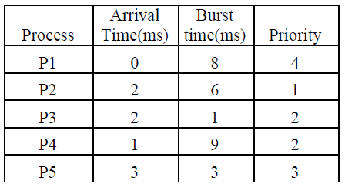

- Assume you have the following jobs shown in the table to execute with one processor. Calculate the average waiting time and average turnaround time if the system uses RR Scheduling and the time slice is 4ms

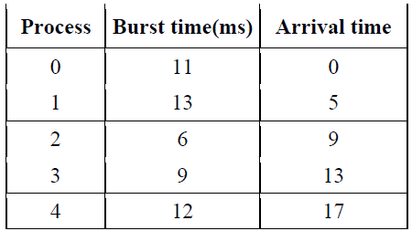

- Draw the Gantt chart and find the average waiting time for the following algorithms: i) FCFS ii) Shortest Remaining Time First iii) Priority Scheduling

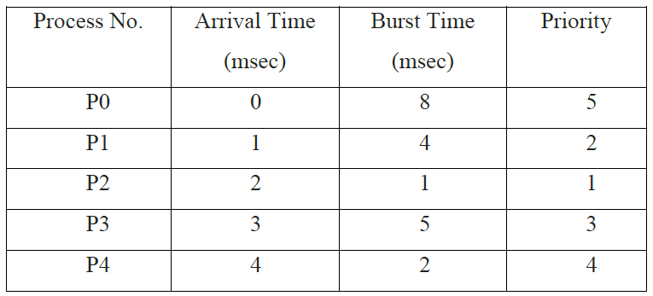

- Discuss the different states of a process.
- What is meant by Process Control Block? Discuss its significance.
- Consider the following set of processes that arrive at time 0 with the length of the CPU burst time given in milliseconds. Schedule the process using Round Robin Scheduling Algorithm.

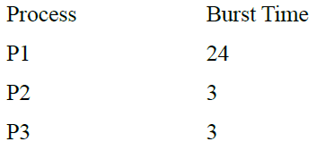
- Define the difference between Preemtive and non-preemptive scheduling.
- Consider the following set of processes that arrive at time 0 with the length of the CPU burst time given in milliseconds. Give the Gantt chart of the process using SJF Algorithm. Also find its average waiting time.

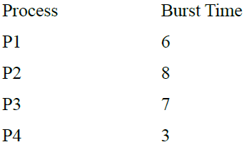
- The long term scheduler directly affects the system performance. Explain how.
- Differentiate thread from a process.
- In a message passing system how the send() / receive() operations and communication link is implemented in case of direct and indirect communication?
- What is process cooperation? What are the benefits of process cooperation?
- How many times “Welcome” will be printed for the following code?
void main() { fork(); fork(); fork(); printf (“Welcome\n”);}
- A writer process like to send some bulk information to a reader process. Explain the IPC mechanism that can be used for the purpose.
- What do you understand by starvation in operating systems? How starvation can be solved in priority scheduling?
- Write the four situations under which CPU scheduling decisions take place.
- What is preemptive scheduling? Give one disadvantage of preemptive scheduling.
- Find the average waiting time and average turnaround time for the processes given in the table below using:- i) SRT scheduling algorithm ii) Priority scheduling algorithm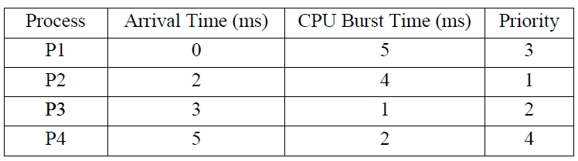
- Consider the following set of processes, with the length of the CPU burst time given in milliseconds. i) Draw Gantt chart to show execution using pre-emptive SJF and Round Robin (time quantum=3) scheduling. ii) Calculate average waiting time for each of the above scheduling algorithms.
